**Lab 8**

**Name :-** Aryan Dilipbhai Langhanoja

**Date :-** 07-08-2023

**Enrollment No :-** 92200133030

**CO1: To write, test, and debug simple Python programs**

**CO2: To implement Python programs with conditional, loops and functions**

**Task 1:- Implementing While Loop**

**Python Code:**

i = 1

while i <= 5 :

print(i)

i = i + 1

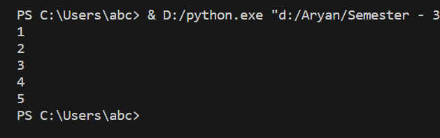**Output:**

**Task 2:- Implementing While Loop with If-else condition and continue statement**

**Python Code:**

i = 0

while i < 9 :

i += 1

if i == 3 :

continue

print(i)

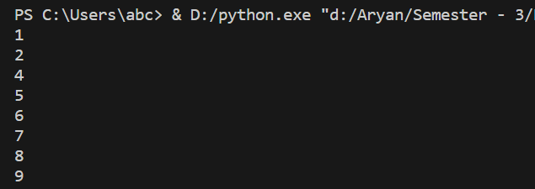**Output:**

**Task 3:- Implementing While Loop with If-else condition and break statement**

**Python Code:**

i = 0

while i < 9 :

if i == 3 :

break

print(i)

i += 1

**Output:**

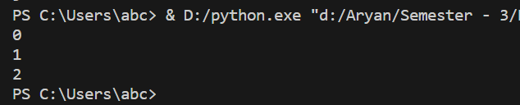

**Task 4:-** **Implementing While Loop with If-else pass statement**

**Python Code:**

i = 0

while i < 9 :

i += 1

if i == 3 :

pass

print(i)

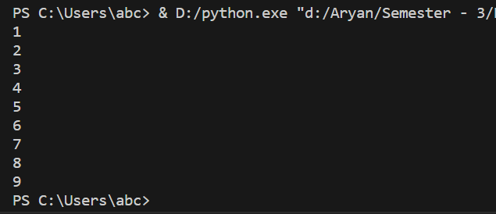**Output:**

**Task 5:- User Define Function**

**Python Code:**

def AryanLAnghanoja() :

print("Hii Aryan Langhanoja")

AryanLAnghanoja()

def Greet(name) :

print(f"Greetings : {name}")

Greet("Aryan Langhanoja")

def Square(num) :

return(num**2)

num = int(input("Enter The Number:-"))

print(Square(num))

**Output:**

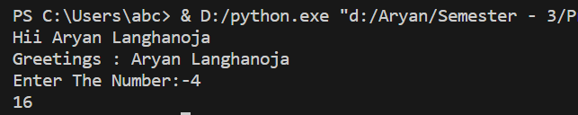

**Task 6:- Function Inside Function**

**Python Code:**

def Out() :

print("Outer Function.")

def In() :

print("Inside Function.")

In()

Out()

**Output**

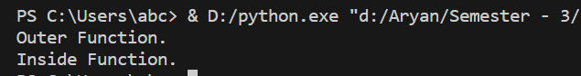

**Task 7:- Lambda Function**

**Python Code:**

Lambda = lambda x:x*3

print(Lambda(5))

**Output:**

**Post Lab**

**Task 1:- Print The Following Pattern**

**Python Code:**

for i in range(1,9) :

for j in range(1,9) :

print(' #',end=' ')

print('\n')

**Output:**

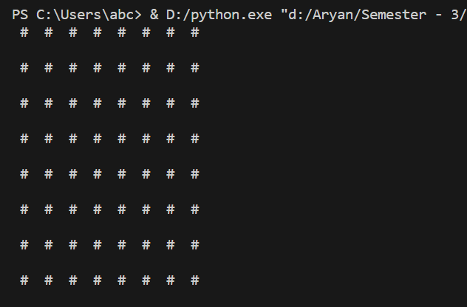

**Task 2:- Use for loop to iterate from 0 to 100 and print the sum of all evens and the sum of all odds.**

**Python Code:**

even = 0

odd = 0

for i in range(0,101) :

if(i % 2 == 0) :

even = even + i

else :

odd = odd + i

print(f"The Sum of All Even Numbers Is {even} and The Sum of All Odd Number Is {odd} Between 1 to 100")

**Output :**



**Task 3 :- Write for loop statement to print the following series:**

**10, 20, 30,… … 300**

**Python Code:**

for i in range(10,301,10) :

print(i,end=" ")

print('\n')

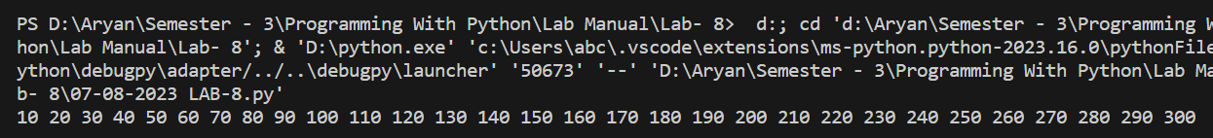**Output:**

**Task 4 :- Write a while loop statement to print following series**

**105, 98, 91 …….. 7.**

**Python Code:**

i = 105

while(i > 0) :

print(i,end=' , ')

i = i - 7

print("\n")

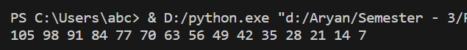**Output:**

**Task 5:- Write a program to check whether a number is prime or not using while loop**

**Python Code:**

num = int(input("Enter The Number :- "))

div = 0

for i in range(2,num) :

if (num % i == 0) :

div += 1

break

if( div > 0 ) :

print(f"{num} Is Not A Prime Number.")

else :

print(f"{num} Is A Prime Number.")

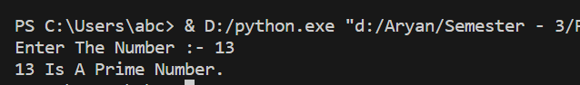**Output:**

**Task 6 :- Write a program to display the number names of the digits of a number entered by user, for example if the number is 431 then output should be 134**

**Python Code:**

num1 = input("Enter The Number:-")

print(f"The Reverse Of {num1} Is {num1[::-1]}")

**Output:**



**Task 7 :- Write a program to convert binary to decimal**

**Python Code:**

num = input("Enter The Binary Number:-")

legth = len(num)

numint = int(num)

ans = 0

for i in range(0,legth) :

digit = numint % 10

ans = ans + (digit * (2**i))

numint = numint / 10

print(f"The Decimal Equvivalent Of Binary Number {num} Is {int(ans)}")

**Output:**

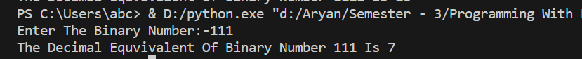

**Task 8 :- Write a program to check whether a number is palindrome or not**

**Python Code:**

num8 = int(input("Enter A Number :- "))

temp = num8

rev = 0

while(temp != 0) :

rev = rev*10 + temp%10

temp = int(temp / 10)

if (num8 == rev) :

print(f"{num8} Is A Palindrome Number.")

else :

print(f"{num8} Is Not A Palindrome Number.")

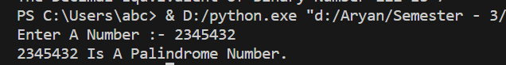**Output:**

**Task 9 :- Write a program to accept 10 numbers from the user and display the largest and smallest number.**

**Python Code:**

list9 = []

num = 0

while (num < 10) :

temp = int(input(f"Enter A Number - {num+1} :- "))

list9.append(temp)

num += 1

print(f"Largest And Smallest Number Of {list9} Is {max(list9)} and {min(list9)}")

**Output:**

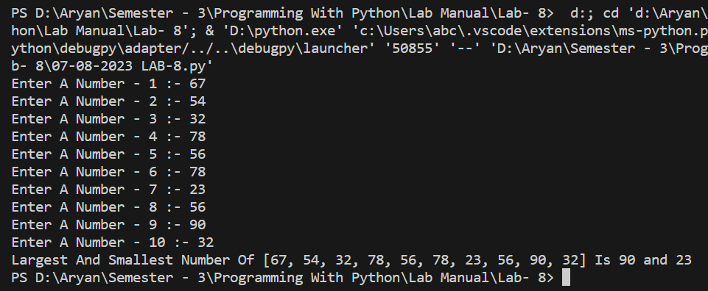

**Task 10 :- Write a program to display all the numbers which are divisible by 13 but not 3 between 100 and 500.**

**Python Code:**

for i in range(100,501) :

if (i % 13 == 0 and i % 3 != 0) :

print(i,end=" ")

**Output:**

**Task 11 :- Write a program to print only odd numbers from the user list using while loop.**

**Python Code:**

user_numbers = []

while True:

num = input("Enter a number (or 'done' to finish): ")

if num.lower() == 'done':

break

num = int(num)

if num % 2 != 0:

user_numbers.append(num)

print("Odd numbers in the list:")

for odd_num in user_numbers:

print(odd_num,end=" ")

**Output:**

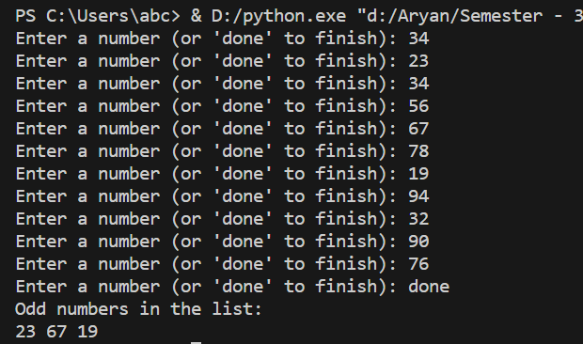

**Task 12 :- Write a Python program to find those numbers which are divisible by 7 and multiples of 5, between 1500 and 2700 (both included).**

**Python Code:**

result = []

for num in range(1500, 2701):

if num % 7 == 0 and num % 5 == 0:

result.append(num)

print("Numbers divisible by 7 and multiples of 5 between 1500 and 2700:")

print(result)

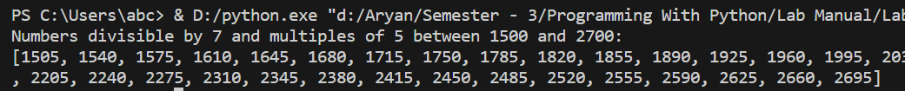**Output:**

**Task 13 :- Write a Python program to find those numbers which are divisible by 7 and multiples of 5, between 1500 and 2700 (both included).**

**Python Code:**

result = []

for num in range(1500, 2701):

if num % 7 == 0 and num % 5 == 0:

result.append(num)

print("Numbers divisible by 7 and multiples of 5 between 1500 and 2700:")

print(result)

**Output:**

